**CIST 0161: The Technology of Computing**

**PC Assembly Final Project**

Student Name:__Drayson Sanders_______

**PC Assembly Questionnaire**

**Demonstration:**

1. PC Successfully POSTS____X____ (75 points)
2. OS Loads Successfully ____X____ (50 points)

**Questionnaire: (2.5 points per question)**

1. How many physical cores does your processor have? Logical? **Our processor has 4 Physical cores and 4 logical cores.**
2. How many threads could your processor handle at a time? **Our processor can handle 8 threads.**
3. Do you have a 32 bit or 64bit processor?**I have a 64 bit processor.**
4. What type of socket does the motherboard provide for the processor?**The motherboard has an AM1(721 pin) socket.**
5. What is the chipset on your motherboard?**The chipset is K16 IMC**
6. What is the speed of your front side bus?**The front side bus speed is 100 MHz.**
7. List all expansion slots (not ports) found on this motherboard.**The motherboard has One PCIe 2.0 x16 and two PCIe x1 slots.**
8. Indicate which portion of the chipset that the expansion slots from question 7 connect to.**They connect directly to the processor.**
9. What is the type and speed of memory used by your motherboard?**The type of memory used is DDR3 and the speed is 1600/1333.**
10. Name all expansion busses and ports that could provide secondary storage on this motherboard.**PCIex16,USB, and SATA**
11. What is the form factor of this motherboard?**ATX**
12. What is the speed in RPM’s, capacity, and cache size of your hard drive?**The speed is 7200 RPM, 80GB, and 8 MB cache.**
13. What was the BIOS type and version before you flashed it? After?**F2 AMD AGESA KabiniPI V1.1.0.0**
14. What is the maximum wattage that your power supply is rated for?**The maximum wattage is 480w.**
15. Name three types of external ports that your system provides. Are they parallel or serial interfaces?**My system provides USB,HDMI(both serial), and VGA(which is parallel tech).**
16. What is the purpose of the battery on your motherboard? What happens if it dies?**The purpose of the battery on the motherboard is to provide power for the CMOS settings and if were to die the time and date would malfunction and would need to be replaced.**
17. What is the fastest bus for *peripherals* on your system?**The fastest bus for peripherals on my system is USB 3.0.**
18. What component of this system would you upgrade to increase overall performance and why? Be detailed and specific. **I would upgrade the RAM in the system so the CPU could process things faster and have more cached data. This would allow the system to execute functions faster and upgrade the overall speed/performance of the system.**

Identify the following components:

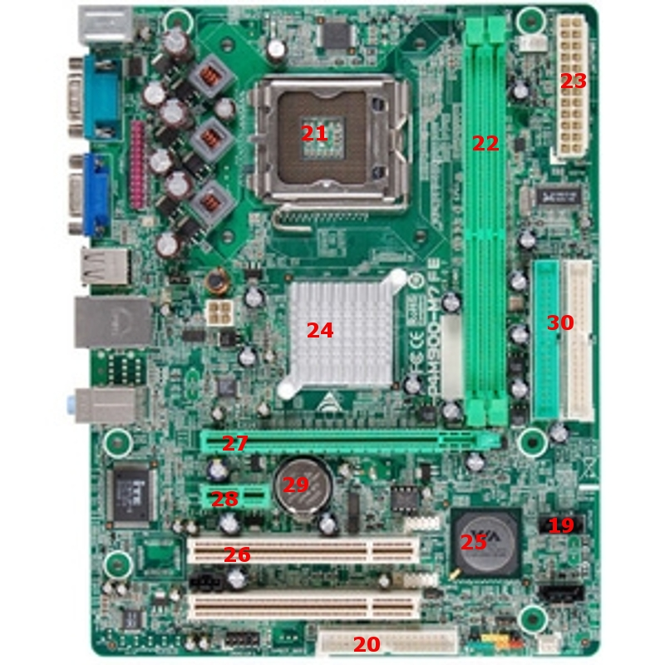

1. SATA
2. IDE Interface

(continued next page)

1. CPU Socket
2. RAM/memory slots
3. P1 power connector
4. Heatsink
5. Southbridge
6. PCIe
7. PCIe x16
8. PCIe x1
9. CMOS Battery